**Azalea Lace Bug**

Azalea Lace Bugs were first documented in Oregon in 2009, but they were not a huge problem until 2012-13. Lace bugs are now very widespread and most everyone who owns azaleas in Portland (some rhododendrons are affected, too) has a Lace Bug problem. Because of this, azaleas can no longer be considered carefree, inexpensive plants.

Since Azalea Lace Bugs are a recent introduction to the Northwest, local research is new and ongoing. This represents our current understanding and we will update our information as new data is available.

**Symptoms:**

Damage from adult Azalea Lace Bugs makes leaves look stippled with yellow or white on top with black & brown spots (bug poo) on the underside of leaves.

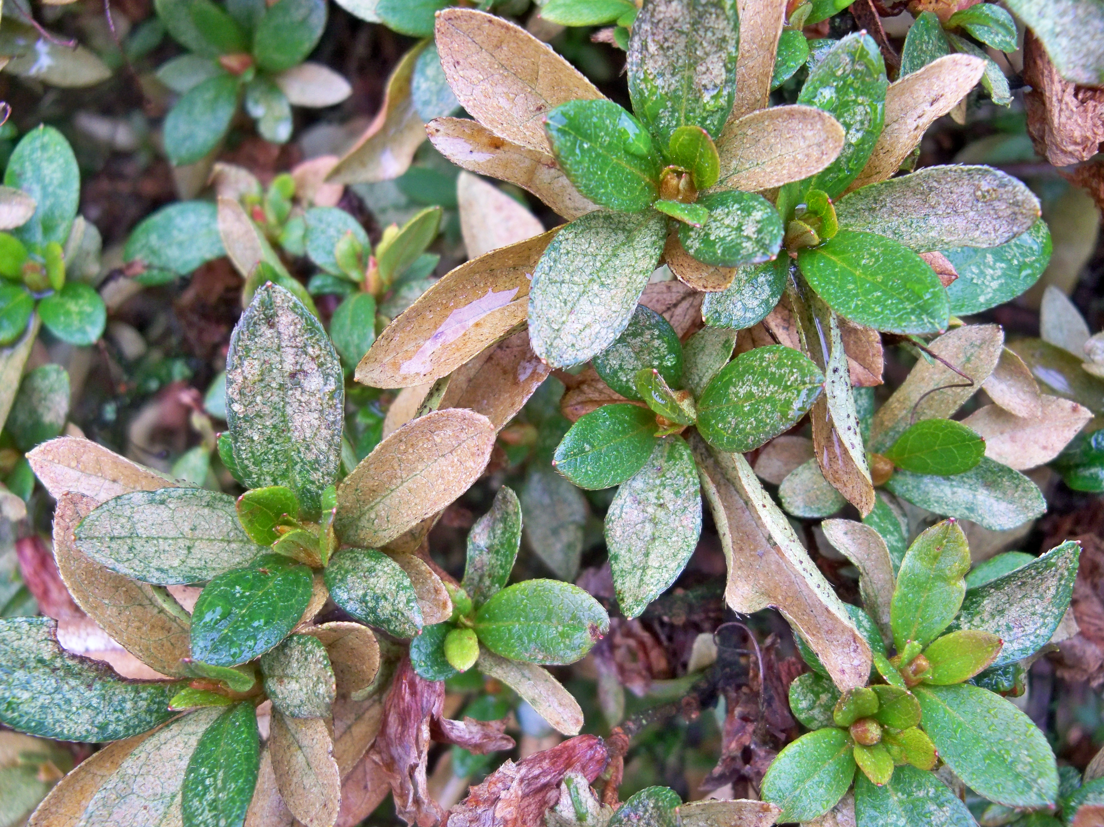

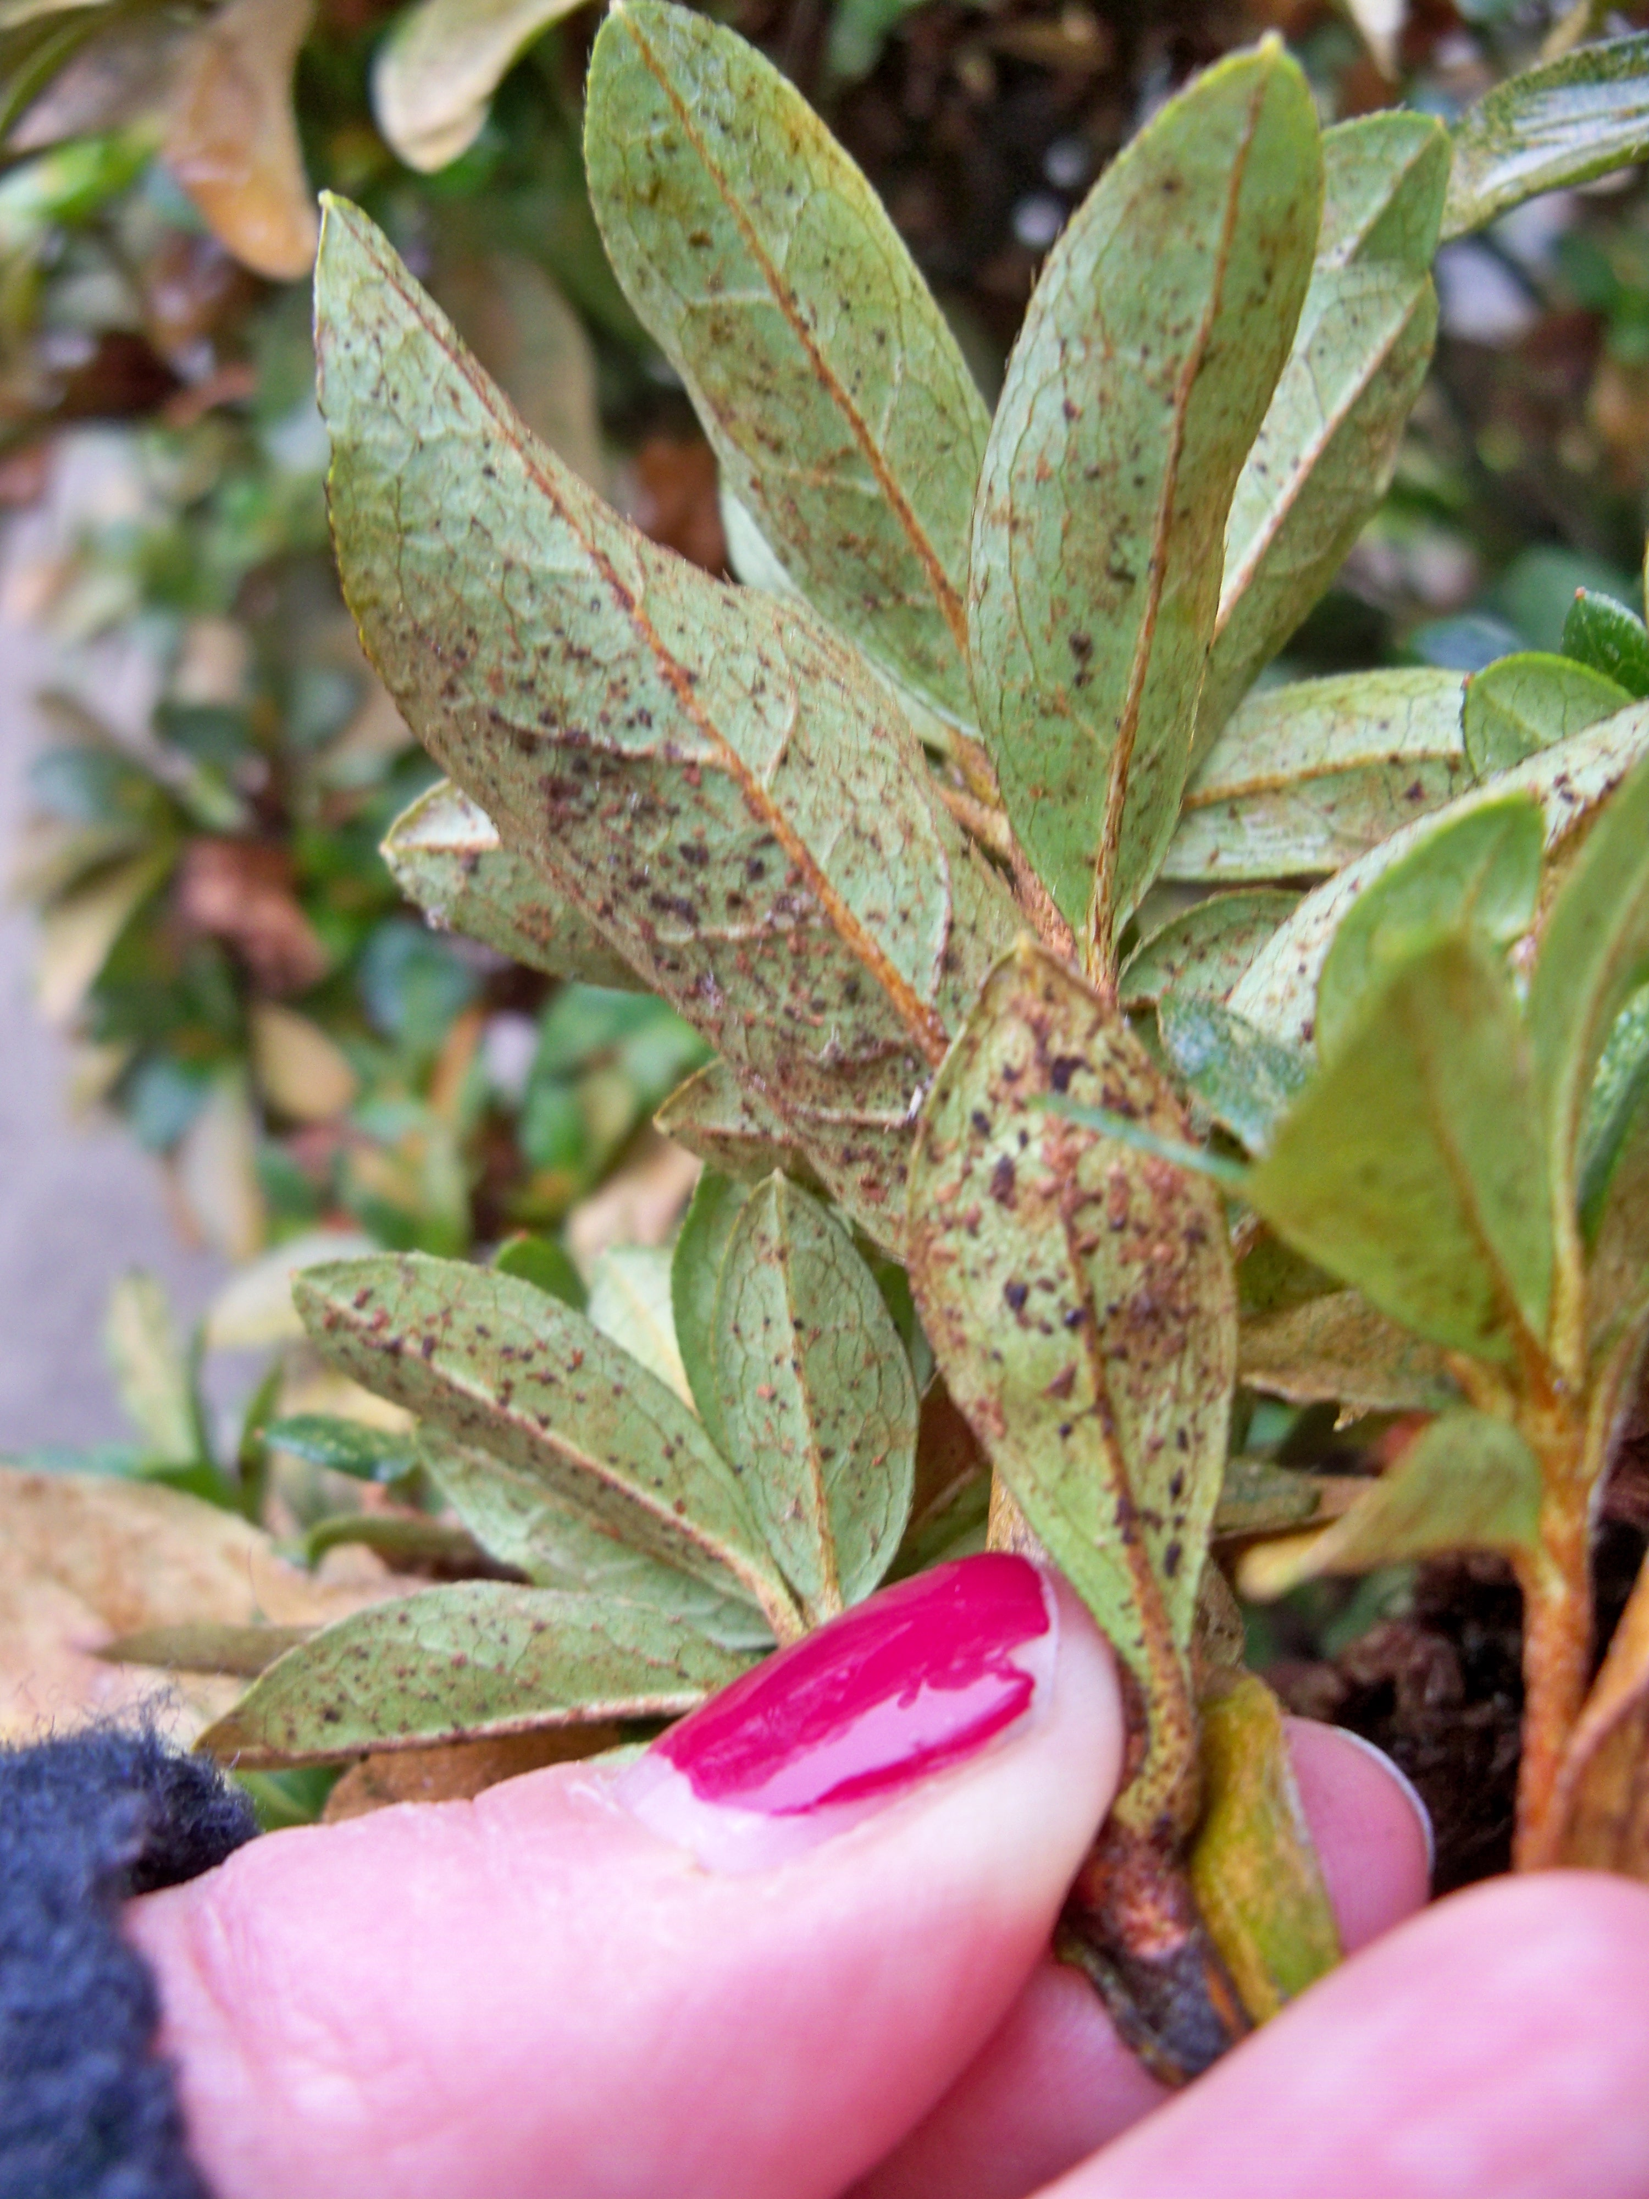

Affected plants are likely to survive attacks for at least a few years; untreated, they’re likely to bounce back and put on healthy new growth in spring, but succumb to attack again in May. Lacebugs suck chlorophyll out of leaves, impairing the plant’s ability to make nutrients from sunlight. Plants attacked often enough can die.

**A few Lacebug facts:**

* Eggs are laid along the midrib, inside of leaves (so spraying with dormant oils may not kill eggs).
* Eggs typically begin hatching in early May but this year some have already

been spotted. They hatch over a long period of time, and a second generation hatches around June, early-July.

* Nymphs are the next stage*. Treatment during the nymph stage is most effective*.
* Adults do 12 times the damage of nymphs. They insert a proboscis (long mouth) into pores in leaves & suck out the chlorophyll, which is what turns affected leaves white or yellow.
* Treating after you notice damage (once adult lacebugs are active) will not remove the stippled appearance of the leaves.
* While adult Azalea Lace Bugs may feed on other types of plants, they are not likely to use them as host plants. Alternate plants probably will not have everything Lace Bugs need to support each stage of life. These plants can be treated for adult Lace Bugs, but nymphs are unlikely to be present.

**Treatment** - Begin treatment when nymphs are visible. Start looking for them in early May on the undersides of leaves. Nymphs are up to ¼” long and translucent with bits of yellow-green. If you’re having trouble seeing them, hold leaves up to a light & look for nymph shadows.

**Chemical-free options**

* Strong stream of water - Nymphs can be knocked off of leaves with a strong stream of water focused on the underside of leaves. If they’re knocked onto the ground, they won’t survive to adulthood. This should be done once a week as long as nymphs are present.

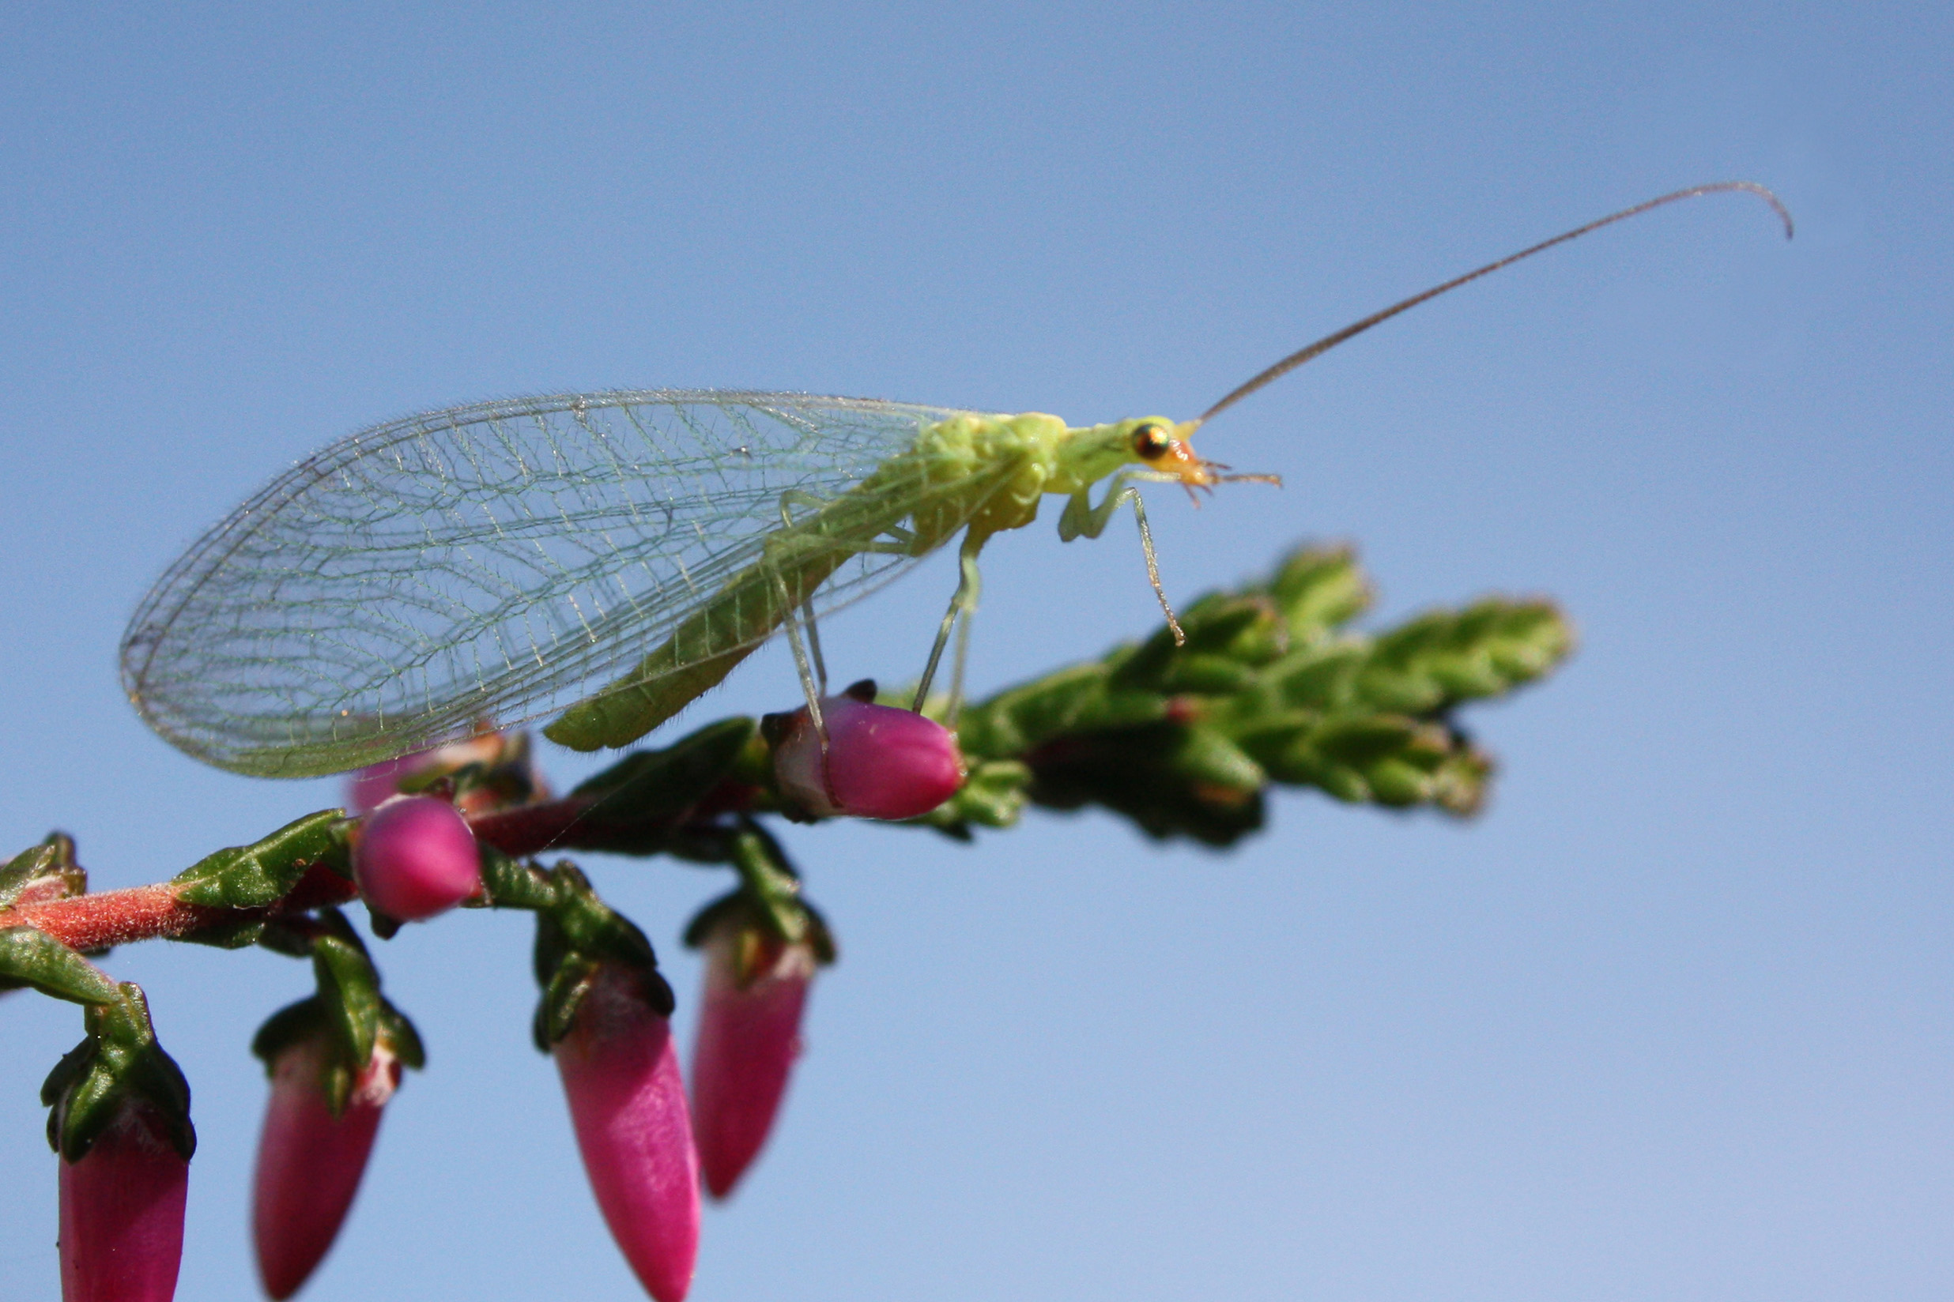

* Biological control - Green Lacewings are beneficial insects that effectively control lace bugs. In spring of 2014 we plan to initiate a mail order program that will broaden access to lacewings.

**Insecticides** – Insecticides will help control Lace Bugs, but may also harm beneficial insects and bees. *Apply only to non-blooming plants, in early morning or evening when bees are not present.*

* Organic & naturally occurring insecticides must have direct contact with insects to be effective.
* Nymphs live on the bottom side of leaves, so use a hose-end or pump sprayer & make sure to coat the undersides of all leaves.
* To be effective, these products will require reapplication several times during hatching season. Follow the directions on the package.

*Listed from least toxic to beneficial insects, bees, pets & humans to most toxic:*

* + Oil – Horticultural oil is an effective control for nymph and adult stages. Dormant oil sprays are listed as a control for eggs, but we worry that because eggs overwinter inside the leaves and would not be exposed to dormant oils, these sprays would not be effective. We’re hoping more studies will be done on the subject, because the ability to control eggs in winter would be a game changer.
  + Insecticidal Soap – works for nymph and adult stages.
  + Pyrethrin – Pyrethrin is effective for use on Lace Bugs but is toxic to beneficial insects & bees and also can be harmful to pets & humans. Use should be limited. Apply to non-blooming plants in early morning or evening. Keep pets indoors until treated areas & the ground around them has dried. Wear long sleeves, gloves, protective glasses & a dust mask during application & don’t apply in an enclosed space.

**Neonicotinoids** – These are a new class of insecticide. Imidacloprid is the most common form of neonicotinoid in systemic insecticides that are available to the public. It’s applied as a root drench, granule, or spray and stays in the system of the plant for varying periods of time, depending on which product is used. Spray and granule applications stay for shorter periods, some as short a time as 4 weeks. Root drench applications persist in plants for a much longer period of time, potentially as long as 6 years.

Insects are killed if they come into contact with sprays and also if they feed on plants treated with these products. Because this insecticide lives in the system of the plant, it kills insects that feed on the plant, which is what makes it so effective when treating lacebug, aphids, scale and mealy bug.

Problems – Products containing imidacloprid can cause harm to bees. As with natural insecticides, if bees and beneficial insects are present when plants are sprayed, they will die. Because imidacloprid and other neonicotinoids persist in the system of treated plants, the insecticides may also make their way into pollen and nectar when flowers bloom, coming into contact with bees. This contact can cause serious problems for bees and may be a contributor to Colony Collapse Disorder, the global decline of honey bees.

Why use it then?

Root drenches are commonly used because they are easy to apply, effective for a long period of time (so multiple applications are not needed), and because there is no drift from spraying (it won’t get on other plants accidentally).

Spray and granule applications are active for shorter periods of time, allowing treatment to be more targeted. If applied after bloom, harm to bees and beneficial insects can be minimized.

Products containing imidacloprid are also less toxic to mammals (pets & humans) than many options that were available previously, and don’t leach into ground water.

If you choose to use a neonicotinoid product:

* Choose products with the shortest active period necessary.
* Apply after bloom is finished or remove flower buds before and during treatment.
* Apply sprays in early morning or evening when bees are not present.
* Read the label and follow the directions.

**Planting options:**

Because treating Azalea Lace Bug is a time consuming and costly investment, consider alternate planting options before choosing azaleas.

**Resistant Azaleas:**

Lace bug has been present on the East Coast for some time now and research has been done to find resistant varieties. Keep in mind that climate differences may change the way these varieties act in the Northwest, and “bug-resistant” does not equal “bug-proof”.



Encore Azalea ‘Autumn Amethyst’

**Encore Azaleas**

Autumn Amethyst

Autumn Twist

Autumn Royalty

Autumn Sangria

Autumn Cheer

Autumn Rouge

**Standard varieties**

Elsie Lee

Flame Creeper

Delaware Valley White

Gumpo White

Hino Crimson

Macrantha

Red Wing

Rosebud

**Rhododendrons**

Rhododendrons are the most logical option to replace azaleas since they have similar flowers and are evergreen, but many rhododendrons are prone to problems with Azalea Lace Bug. However, there is a large group of rhododendrons that have leaves which are covered in thick fuzz (indumentum) on the back side, and we think these varieties will be naturally resistant. Since the lace bug attacks by inserting a very long nose into the leaf and sucking out the chlorophyll, the thick fuzz would create a sizeable barrier. Look for *Yaku Hybrid* *Rhododendrons* or check the back side of leaves when shopping.

**Additional Shade options:**

There is really nothing that produces the same colorful show and evergreen coverage as azaleas, but there are plenty of great alternatives. Consider combining evergreen plants with colorful perennials or deciduous shrubs to brighten shady garden areas.

**Colorful Perennials**

Dicentra – Bleeding Heart

Helleborus – Lenten Rose

Heuchera & Heucherella

Hardy Fuchsia

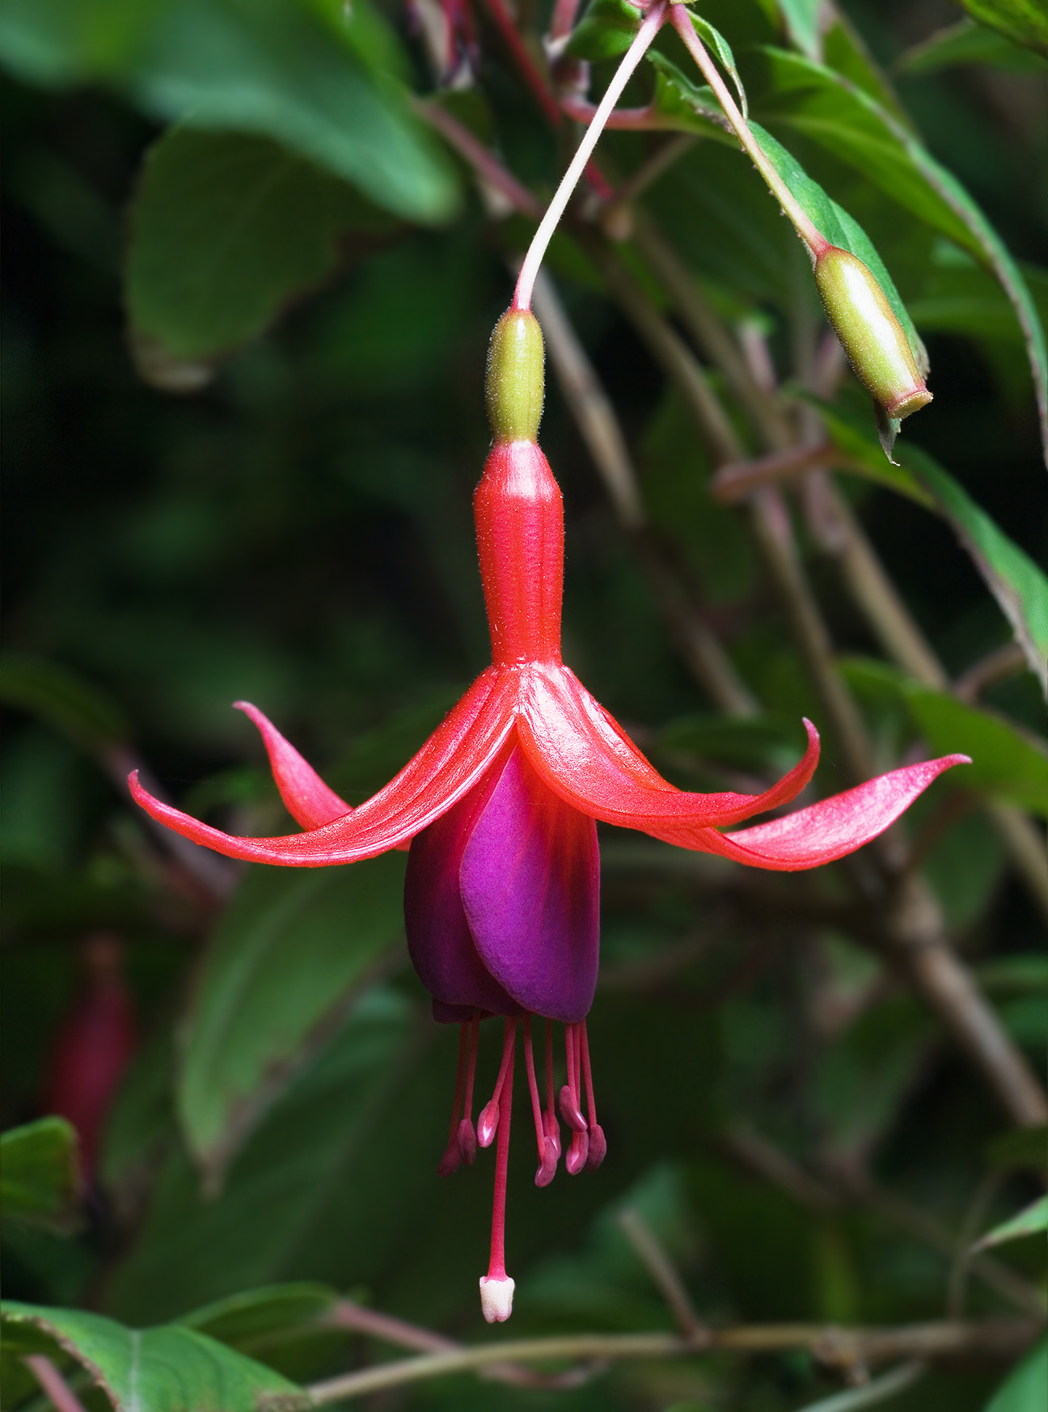

Fuchsia magellanica

**Evergreen Shrubs for Shade**

Camellias – low-growing varieties ‘Bonanza’, ‘Chansonette’, ‘White Doves’ & ‘Shishigashira’(shown below)

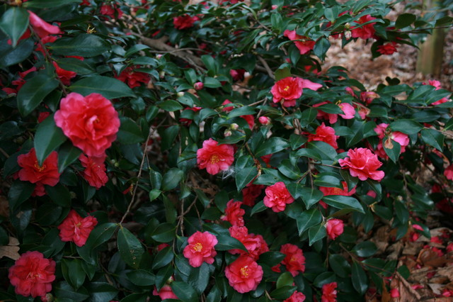

Choisya – Mexican Orange

Daphne odora – Winter Daphne

Cephalotaxus ‘Duke Garden’ – Yew Plum

Low-growing Mahonias – Oregon Grape

Leucothoe – Fetter Bush

Dwarf Pieris – Andromeda

Sarcococca – Sweet Box

Vaccinium ovatum – Evergreen Huckleberry

Read more about Azalea Lace Bug & Integrated Pest Management

<http://www.ipm.ucdavis.edu/PMG/PESTNOTES/pn7428.html>

<http://oregonstate.edu/dept/nurspest/Azalea_lacebug.pdf>

Read more about Neonicotinoides & Colony Collapse Disorder

<http://www.xerces.org/neonicotinoids-and-bees/>

<http://science.howstuffworks.com/zoology/insects-arachnids/colony-collapse-disorder.htm>

<http://www.usnews.com/news/blogs/at-the-edge/2013/08/07/bee-colony-collapses-are-more-complex-than-we-thought>